**Final Year Project Document**

**Version 2.2**

**Student Support and Navigation App - SSNA**

**FYP Team**

**Muhammad Ashar Zafar 20F - 0240**

**Muhammad Ehsan Akhtar 20F - 0312**

**Muhammad Shahzaib Shafiq 20F - 0317**

**Supervised by:**

**Mr. Tahir Farooq**

**Co - supervised by:**

**Ms. Areeba Waseem**

**Department of Computer Science**

**National University of Computer and Emerging Sciences**

**Chiniot - Faisalabad Campus, Pakistan.**

**2023**

**Table of Contents**

I

1. Introduction 1

2. Vision Document 1

2.1. Problem Statement 1

2.2. Business Opportunity 1

**2.2.1. Licensing to Universities 1**

**2.2.2. In-App Advertising: 2**

**2.2.3. Career Services Integration: 2**

**2.2.4. Data Analytics for Universities: 2**

**2.2.5. Security and Privacy Services: 2**

2.3. Objectives 3

2.4. Scope 3

2.5. Constraints 3

**2.5.1. Technical Constraints: 3**

**2.5.2. Data Privacy and Security: 4**

**2.5.3. Integration Challenges: 4**

**2.5.4. User Adoption: 4**

**2.5.5. Scalability: 4**

**2.5.6. Limited Mobile Device Capabilities: 4**

**2.5.7. Testing and Quality Assurance: 4**

2.6. Stakeholder and User Description 5

**2.6.1 Market Demographics: 5**

**2.6.2 Stakeholder Summary: 5**

**2.6.3 User Environment: 5**

**2.6.4 Stakeholder Profiles 6**

3. System Requirement Specifications 6

3.1. System Features 6

**3.1.1. User Authentication and Profiles: 6**

**3.1.2. Academic Resources: 6**

**3.1.3. Communication Tools: 6**

**3.1.4. Event Listings: 6**

**3.1.5. Campus Map: 7**

**3.1.6. News and Updates: 7**

**3.1.7. User Directory: 7**

**3.1.8. User Engagement and Social Features: 7**

II

**3.1.9. Notifications and Alerts: 7**

**3.1.10. Security and Privacy: 7**

**3.1.11. Customization and Branding (optional): 7**

**3.1.12. Help and Support: 7**

3.2. Functional Requirements 8

**3.2.1. User Authentication: 8**

**3.2.2. User Profiles: 8**

**3.2.3. Academic Resources: 8**

**3.2.4. Communication Tools: 8**

**3.2.5. Event Management: 8**

**3.2.6. Campus Map: 8**

**3.2.7. News and Updates: 9**

**3.2.8. User Directory: 9**

**3.2.9. User Engagement and Social Features: 9**

**3.2.10. Virtual Campus Tours: 9**

**3.2.11. Security and Privacy: 9**

**3.2.12. Customization and Branding: 9**

3.3. Non-Functional Requirements 9

**3.3.1. Performance: 10**

**3.3.2. Security: 10**

**3.3.3. Reliability: 10**

**3.3.4. Usability and Accessibility: 10**

**3.3.5. Compatibility: 10**

**3.3.6. Data Privacy and Compliance: 11**

**3.3.7. Performance Monitoring: 11**

**3.3.8. Network and Connectivity: 11**

**3.3.9. Load Testing: 11**

**3.3.10. Compliance with Standards: 11**

**3.3.11. User Support and Documentation: 11**

**3.3.12. Maintenance and Updates: 12**

**3.3.13. Legal and Compliance: 12**

List of tables

III

3.4. Use Cases 12

3.4.1. Fully Dressed 12

Table 1: Manage Course Material 12

Table 2: Manage Announcements 12

Table 3: Manage Guidance Portal 13

Table 4: Manage Events 13

Table 5: Manage Timetable 14

Table 6: Manage Faculty Info 14

Table 7: Manage Buses 14

Table 8:Access guidance portal 15

3.4.2. Brief Use Cases 15

Table 1: Login 15

Table 2: Authentication 16

Table 3: Browse course material 16

Table 4: View Announcements 16

Table 5: View events 16

Table 6: View Timetable 16

Table 7: Enable reminders. 17

Table 8: Access faculty information 17

Table 9: Manage Profile 17

Table 10: Get Location 17

Table 11: Approve requests 17

Table 12:Search bus routes 18

Table 13**:** Download material 18

Table 14: Post query ..……………………………………..…………....18

List of figures

IV

4. Diagrams 18

4.1. Use Case Diagram 18

Figure 1. Use Case Diagram 19

4.2. Activity Diagram 19

Figure 2. Activity Diagram 1 20

Figure 3. Activity Diagram 2 21

Figure 4. Activity Diagram 3 22

Figure 5. Activity Diagram 4 23

Figure 6. Activity Diagram 5 24

Figure 7. Activity Diagram 6 25

Figure 8. Activity Diagram 7 26

4.3. System Sequence Diagram 27

Figure 9. System Sequence Diagram (SSD) 1 27

Figure 11. System Sequence Diagram (SSD) 3 28

Figure 12. System Sequence Diagram (SSD) 4 29

Figure 13. System Sequence Diagram (SSD) 5 30

Figure 14. System Sequence Diagram (SSD) 6 31

Figure 15. System Sequence Diagram (SSD) 7 32

Figure 16. System Sequence Diagram (SSD) 8 33

Figure 17. System Sequence Diagram (SSD) 9 34

4.4. Component Diagram 35

Figure 18. Component Diagram 35

4.5. Data Flow Diagram 36

Figure 19. Data Flow Diagram 1 36

Figure 20. Data Flow Diagram 2 37

Figure 21. Data Flow Diagram 3 38

4.6. Database Schema 39

Figure 22. Database Schema 1 39

# **Introduction**

In the age of digitalization, all universities and colleges are searching for creative methods to provide students with a more engaging and varied experience that includes opportunities from both social and intellectual circles. We are pleased to notify you about the project we are now working on, which involves creating a mobile application from scratch just for university circles, in recognition of the evolving demands of today's students. It is envisaged that this application would make life on campus for students easier in terms of their academics and will promote convenience, interaction, and communication. It is anticipated that the features would cover everything from effective study tools to making the most of a student's time at school.

# **Vision Document**

## **Problem Statement**

A central platform that would benefit the students in the current system, as it is quite difficult for new students to navigate the schedule, the classrooms, and the support of their seniors. Our software aims to address these kinds of issues by giving the students a one-stop shop to assist them in completing all these tasks on a single platform. This unified system will facilitate all aspects of university student life, including scheduling, class locations, and connecting with more seasoned classmates.

## **Business Opportunity**

Developing a comprehensive university mobile app opens several business opportunities that can benefit both educational institutions and students. Here are few potential ways we can leverage our app:

* + 1. ***Licensing to Universities:*** Universities who want to rename and modify the software can purchase a license from us. As a result, under this scenario, each university assigned the task of branding the application for its needs and branding would have to make it user- or feature-based, with fixed price that is naturally adaptable to suit the needs of various sized institutions.
    2. ***Career Services Integration:*** Gain access to the internship and student employment listings by working with the career assistance office. For companies to review them and, if interested, get in touch with the students for an interview, students may attach their resumes to the application. Employers should also be allowed to publish job openings on the app for a charge, and they should have the opportunity to sell their brands via it in exchange for targeted and concentrated access to the student body. This allows reputable companies to take advantage of the talent pool inside the university's student body and helps students have a decent chance of pursuing their professional goals.
    3. ***Security and Privacy Services:*** The application is capable of and prepared to abide by all privacy laws. The highest priority will be given to protecting user data. We may also give colleges private services and premium security, giving them the assurance that any information coming from their end is safe and secure. It is certain that students at universities that pay for premium services won't experience any privacy infringement when using the app.

## **Objectives**

* New students often struggle to understand their timetables.
* Providing PDFs and other course materials (like slides and books) is essential.
* Interaction with seniors for guidance is crucial, but there isn't a straightforward way to do this.
* Newcomers need an easy-to-use campus map to navigate the university.
* Timetable management is vital for making the most of students' time.
* Contact information for various departments should be easily accessible.

## **Scope**

We are eager to think of ways that a mobile app may specifically benefit the campus community, improving and perhaps adding to the quality of life for students. Everything they would require for classes including timetables, e-books, and even syllabus would be provided, along with an academic calendar that would remember all the important dates. Along with that, it has a university-wide announcement and options for communicating with friends, peers, and seniors. Students will be able to navigate through all the events and activities taking place on campus with ease because of the website's simplicity of opening. They offer several news streams that will provide updates on events on the campus. Moreover, a portal providing access to several student support services is included.

## **Constraints**

While developing the university mobile app, we may encounter several constraints that could impact the project. These constraints may include:

1. ***Technical Constraints****:* Compatibility issues may arise with different mobile devices and operating systems, for which the development and testing efforts will have to increase. Our goal is to make sure that everyone can enjoy the app with no glitches. Our goal is to make sure a seamless experience is provided to everyone who has installed it, irrespective of the type of device or OS in use.
2. ***Data Privacy and Security****:* There are stringent data privacy laws, such as the PDP bill, in Pakistan that lay down stringent rules in dealing with and storing data. It implies that security measures are to be at the highest level and quite robust; otherwise, compliance will be very nominal and time-consuming. This is required to keep all this information about people safe and sound.
3. ***Integration Challenges****:* Integration with our current university systems will mainly involve the SIS student information system, which will be complicated. It must involve collaboration by different departments to make it work in harmony. We, in this respect, shall have to work hand in hand with everyone involved to achieve perfect integration that benefits all users.
4. ***User Adoption****:* This is one of the challenges because convincing students to use applications daily is not an easy feat. This may involve great marketing and onboarding techniques having much more creativity — which can be shown to them regarding how valuable this application is and how simple it is to kick-start their lives on campus.
5. ***Scalability****:* The app should support our growing university community. More importantly, an app should be formed in a way that it can quickly scale up and down and, hence, have the most minor effect on our infrastructure and application performance. All this scaling will ensure everybody has a pleasant experience with the app.
6. ***Limited Mobile Device Capabilities****:* We have to remember that there can be users with old or low-performance mobile devices, so this may result in our application not supporting whatever advanced feature we would like to implement in it. That is not so important, though, because, anyway, our app has to work correctly for every device a person uses. We must also find a golden middle way to the advanced opportunities for a user and find simplicity that he really must get in using the app.
7. ***Testing and Quality Assurance****:* It is critically important that the app be thoroughly tested on more devices and operating systems to help make sure the app works with no flaws for all users, but this usually becomes lengthy. Some of this lengthy testing may elongate the timeline of the project. Extra time must be considered to come up with a fine product that is fit for day-to-day use without moving at speed through the vital steps.

## **Stakeholder and User Description**

### ***Market Demographics:***

Our app is for public and private universities, considering primarily the students but accommodating school visitors. It is custom-tailored to fit into a variety of academic fields with diverse undergraduate student groups and those at the graduate and professional levels. We do have this broad focus intending to better the campus life of specific needs for a wide variety of audiences.

### ***Stakeholder Summary:***

The stakeholders in such a project are assumed to be critical. This will be inclusive of the university administration because they deal with campus technologies and services, and they will be the users of the application and its functionalities. The students are also crucial; they will be the prominent people using the app, other than the potential students trying to know more about the institution. The external stakeholders could be a third-party service provider or the local businesses looking to offer specific services or advert products to the students and the university community. All these stakeholders need to be human-centred and well-engaged to make the app successful and widely adopted.

### ***User Environment:***

In such a technology project, such stakeholders would be the university administrators responsible for controlling the campus technology and services since they are the ultimate users of the app with its functionalities. Finally, student bodies form an integral part because they are, after all, the end users. It will also be prospective students who would like to discover the institution. The other important component of external stakeholders is the third-party service providers and local businesses willing to reach out to the campus community. It is essential for stakeholders to be engaged and work persistently with them throughout the process of development to ensure that there is success and adoption of the app.

### ***Stakeholder Profiles***

* **University Administrators:** Administer and run the app and be sure that it is in tandem with the college's strategic objectives. In addition, this would ensure that the app integrates with prior enacting college systems.
* **Students:** This would be the most highly targeted group, and students will access academic resources, event updates, and communication through the app. Students would also use the app to receive student services.
* **Prospective Students:** The app enables a student to tour campus and learn about academic programs.
* **Local Businesses and Advertisers:** Could potentially advertise through the app in the future to provide discounts or specials to the campus community.

# **System Requirement Specifications**

## **System Features**

* + 1. ***User Authentication and Profiles:***

This is the registration interface, which is safe and straightforward for users to log in. Users need to get a profile; there should be a profile for students and even guests. A profile would include a photo, contact information, and academic details.

* + 1. ***Academic Resources****:*

Course Schedule, Syllabus, and Assignments. E-Textbooks along with the Downloading of Other Course Materials. Academic Calendar: Important Dates.

* + 1. ***Communication Tools****:*
* General university announcements and push notifications. Forums or discussion boards for academic and non-academic discussions.
  + 1. ***Event Listings****:*
* List of events, workshops, and activities of campus activities.
  + 1. ***Campus Map****:*
* Campus map with relevant locations.
  + 1. ***User Directory****:*
* Directory of faculty and staff for easy contact and networking.
* Search and filter options for finding specific individuals.
  + 1. ***User Engagement and Social Features****:*
* User-generated content, including reviews, ratings, and comments on events and courses. *(optional)*
  + 1. ***Notifications and Alerts****:*
    - Push notifications for important updates, deadlines, and events.
    1. ***Security and Privacy****:*
* Robust security measures to protect user data and privacy.
* Compliance with relevant data protection regulations.
  + 1. ***Customization and Branding (optional)****:*
* Customization options for universities to brand the app with their logos and colors.
* University-specific content and features.
  + 1. ***Help and Support****:*
* Help center or knowledge base for users to find answers to common questions.
* Customer support and feedback channels for assistance and issue resolution.

These features are designed to create a comprehensive and user-friendly mobile app that meets the needs of the university community. Our goal is to make campus life more engaging and convenient for everyone involved.

## **Functional Requirements**

The precise features, interactions, and functions that the university mobile app must have in order to achieve its goals are outlined in the functional requirements. The following features must be included in the university mobile app:

* + 1. ***User Authentication****:*
       - Users can login through the official email address allotted to them by the university.
    2. ***User Profiles****:*
       - User profiles display user type (student, alumni, guest) and profile picture.
    3. ***Academic Resources****:*
       - Students can access course schedules, syllabus, and assignments.
       - Users can view and download digital textbooks and course materials.
    4. ***Communication Tools****:*
       - Users can discuss queries with registered seniors on portal within the app.
       - University administrators can send announcements to all users.
    5. ***Event Management****:*
       - Event organizers can create, edit, and manage events.
       - Users can browse and search for events, workshops, and activities.
       - Users can RSVP to events, receive event reminders, and view event details.
    6. ***Campus Map****:*
       - The app provides a campus map with searchable locations.
    7. ***User Directory****:*
       - Users can search for and contact faculty within the app.
       - The directory displays user details, including name and contact information.
    8. ***Virtual Campus Tours****:*
       - Prospective students can take virtual campus tours using map.
       - Tours include information about campus facilities and courses offered.
    9. ***Security and Privacy****:*
       - Robust security measures protect user data and privacy.
       - Compliance with data protection regulations, including user consent for data processing.
    10. ***Customization and Branding****:*
        - Universities can customize the app with their branding, logos, and colors.
        - University-specific content and features can be added.

These functional requirements are essential to ensure that the university mobile app meets the needs of its users and provides a seamless and engaging experience.

## **Non-Functional Requirements**

Non-functional requirements focus on the overall qualities and characteristics of the university mobile app, rather than its specific features. These requirements are crucial because they cover performance, security, usability, and compliance aspects of the app. Ensuring the app meets high standards in these areas is essential for delivering a great user experience and maintaining safety:

* + 1. ***Performance****:*
       - **Response Time:** For most interactions, the app should react to user inputs in five seconds or less.
       - **Scalability:** The application must support a growing user base without seeing a noticeable drop in functionality.
    2. ***Security****:*
       - **Data Encryption:** Industry-standard protocols should be used to encrypt user data and conversations.
       - **Authentication:** Ensuring the security of user data requires the use of robust authentication protocols.
       - **Access Control:** To limit access to sensitive information and features, role-based access control should be put into place.
    3. ***Reliability****:*
       - **Uptime:** During periods of peak demand, the app should be available at least 80% of the time.
       - **Backup and Recovery:** It is recommended to have both a disaster recovery strategy and regular data backups.
    4. ***Usability and Accessibility****:*
       - **User Interface:** The app should have an intuitive and user-friendly interface.
       - **Accessibility:** The application must adhere to accessibility guidelines, ensuring that people with impairments may utilize it.
    5. ***Compatibility****:*
       - **Device Compatibility:** The software needs to function flawlessly across a range of mobile screen sizes.
       - **Browser Compatibility:** Should an online version be accessible, it need to work with the majority of popular web browsers.
    6. ***Data Privacy and Compliance****:*
       - **Data Privacy:** The app should adhere to relevant data protection regulations (e.g., PDP).
       - **Data Retention:** Clear policies for data retention and deletion should be defined.
    7. ***Performance Monitoring****:*
       - **Logging:** The app should log errors, user activities, and security events for monitoring and auditing purposes.
    8. ***Network and Connectivity****:*
       - **Offline Mode:** The app should provide limited functionality when offline, with data synchronization once a connection is restored.
       - **Network Resilience:** The app should handle network disruptions gracefully.
    9. ***Load Testing****:*
* The app should be subjected to load testing to ensure it can handle peak usage without performance degradation.
  + 1. ***Compliance with Standards****:*
       - **Coding Standards:** Adherence to coding and development standards should be maintained.
       - **Industry Best Practices:** Industry best practices for mobile app development should be followed.
    2. ***User Support and Documentation****:*
       - **User Support:** A help center, or user support system should be available.
       - **Documentation:** Comprehensive user and administrator documentation should be provided.
    3. ***Maintenance and Updates:***
       - **Regular Updates:** The app should receive regular updates to fix bugs, add new features, and address security vulnerabilities.
    4. ***Legal and Compliance****:*
       - **Copyright and Licensing:** Verify that the program abides with license agreements for third-party libraries and resources as well as copyright laws.

These non-functional requirements are essential for ensuring that the university mobile app not only functions properly but also meet high standards of performance, security, and user experience.

## **Use Cases**

**USE CASES SPECIFICATION**

## Fully Dressed

### Table 1: Manage Course Material

|  |  |
| --- | --- |
| **Use case Name** | Manage Course Material |
| **Use Case ID** | UC-01 |
| **Description** | Admin manage course material including Books, Lectures |
| **Primary Actors** | Admin |
| **Secondary Actors** | Student |
| **Preconditions** | Admin opens a course material portal to manage material. |
| **Main Flow** | Admin edits/uploads/removes course books/slides. |
| **Post conditions** | Admin successfully completed the task. |
| **Alternative Flow** | Error while uploading course material. |

### Table 2: Manage Announcements

|  |  |
| --- | --- |
| **Use case Name** | Manage Announcements |
| **Use Case ID** | UC-02 |
| **Description** | Admin manages announcements |
| **Primary Actors** | Admin |
| **Secondary Actors** | Student |
| **Preconditions** | Admin opens an announcement portal. |
| **Main Flow** | Admin makes an announcement on the portal. |
| **Post conditions** | Announcement successfully posted. |
| **Alternative Flow** | Error while making an announcement. |

### Table 3: Manage Guidance Portal

|  |  |
| --- | --- |
| **Use case Name** | Manage Guidance Portal |
| **Use Case ID** | UC-03 |
| **Description** | Admin manages guidance portal |
| **Primary Actors** | Admin |
| **Secondary Actors** | Student |
| **Preconditions** | Admin manages a guidance portal to approve student query requests. |
| **Main Flow** | Admin monitors guidance portal to approve junior student queries and senior’s responses. |
| **Post conditions** | Guidance approval failed. |

### Table 4: Manage Events

|  |  |
| --- | --- |
| **Use case Name** | Manage Events |
| **Use Case ID** | UC-04 |
| **Description** | Admin manages events. |
| **Primary Actors** | Admin |
| **Secondary Actors** | Student |
| **Preconditions** | Admin opens an event portal. |
| **Main Flow** | Admin manages event portals and updates. |
| **Post conditions** | Admin completes the required task. |
| **Alternative Flow** | Event Upload Failed. |

### Table 5: Manage Timetable

|  |  |
| --- | --- |
| **Use case Name** | Manage Timetable |
| **Use Case ID** | UC-05 |
| **Description** | Admin manages timetables. |
| **Primary Actors** | Admin |
| **Secondary Actors** | Student |
| **Preconditions** | Admin requires timetables data. |
| **Main Flow** | Admin upload/updates/deletes the timetables. |
| **Post conditions** | Operation successful. |
| **Alternative Flow** | Event Upload Failed. |

### Table 6: Manage Faculty Info

|  |  |
| --- | --- |
| **Use case Name** | Manage Faculty Info |
| **Use Case ID** | UC-06 |
| **Description** | Admin manages faculty information. |
| **Primary Actors** | Admin |
| **Secondary Actors** | Student |
| **Preconditions** | Admin gets the faculty information from faculty. |
| **Main Flow** | Admin updates/deletes the faculty information and uploads it on the portal. |
| **Post conditions** | Operation successful. |
| **Alternative Flow** | Faculty Upload/Update Failed. |

### Table 7: Manage Buses

|  |  |
| --- | --- |
| **Use case Name** | Manage Buses |
| **Use Case ID** | UC-07 |
| **Description** | Admin manages bus routes information. |
| **Primary Actors** | Admin |
| **Secondary Actors** | Student |
| **Preconditions** | Admin gets the bus routes data from the transport department. |
| **Main Flow** | Admin updates/deletes the bus information and uploads it on the portal. |
| **Post conditions** | Operation successful. |
| **Alternative Flow** | Bus information Upload/Update Failed. |

### Table 8:Access guidance portal

|  |  |
| --- | --- |
| **Use case Name** | Access guidance portal |
| **Use Case ID** | UC-09 |
| **Description** | Student can post any query. |
| **Primary Actors** | Student |
| **Secondary Actors** | Admin/Student |
| **Preconditions** | Student opens a guidance portal. |
| **Main Flow** | Any registered student can make any query, admin can approve or disapprove it. Senior student then posts any response. Admin has to approve or disapprove it as well. |
| **Post conditions** | Operation successfully completed. |
| **Alternative Flow** | Error while making any operation. |

## Brief Use Cases

### Table 1: Login

|  |  |
| --- | --- |
| **Use case** | Login |
| **Actors** | Student and Admin |
| **Type** | Primary |
| **Description** | Student and admin can login to SSNA application. |

### Table 2: Authentication

|  |  |
| --- | --- |
| **Use case** | Authentication |
| **Actors** | Admin and Student |
| **Type** | Primary |
| **Description** | Admin and student both are authenticated by nu email. |

### Table 3: Browse course material

|  |  |
| --- | --- |
| **Use case** | Browse course material |
| **Actors** | Student |
| **Type** | Primary |
| **Description** | Students can view or access any course material such as books/slides. |

### Table 4: View Announcements

|  |  |
| --- | --- |
| **Use case** | View announcements |
| **Actors** | Student |
| **Type** | Primary |
| **Description** | Students can view announcements posted by the admin. |

### Table 5: View events

|  |  |
| --- | --- |
| **Use case** | View events |
| **Actors** | Student |
| **Type** | Primary |
| **Description** | Students can get event updates and other information. |

### 

### Table 6: View Timetable

|  |  |
| --- | --- |
| **Use case** | View timetable |
| **Actors** | Student |
| **Type** | Primary |
| **Description** | Students can view or select the desired timetable. |

### Table 7: Enable reminders.

|  |  |
| --- | --- |
| **Use case** | Enable reminders |
| **Actors** | Student |
| **Type** | Primary |
| **Description** | Students can set a reminder for upcoming lectures. |

### 

### Table 8: Access faculty information

|  |  |
| --- | --- |
| **Use case** | Access faculty information |
| **Actors** | Student |
| **Type** | Primary |
| **Description** | Students can access faculty information |

### Table 9: Manage Profile

|  |  |
| --- | --- |
| **Use case** | Manage Profile |
| **Actors** | Student |
| **Type** | Primary |
| **Description** | Students can Update their profile |

### Table 10: Get Location

|  |  |
| --- | --- |
| **Use case** | Get location |
| **Actors** | Student |
| **Type** | Primary |
| **Description** | Students can navigate through campus using maps. |

### Table 11: Approve requests

|  |  |
| --- | --- |
| **Use case** | Approve requests |
| **Actors** | Admin |
| **Type** | Primary |
| **Description** | Admin approves students queries that are posted in senior guidance portal for check and balance. |

### Table 12:Search bus routes

|  |  |
| --- | --- |
| **Use case** | Search bus routes |
| **Actors** | Student |
| **Type** | Primary |
| **Description** | Students can search for buses departure and arrival. |

### Table 13**:** Download material

|  |  |
| --- | --- |
| **Use case** | Download material |
| **Actors** | Student |
| **Type** | Primary |
| **Description** | Students can download any course material such as books/slides. |

### Table 14: Post query

|  |  |
| --- | --- |
| **Use case** | Post query |
| **Actors** | Student |
| **Type** | Primary |
| **Description** | Students can post any query in the guidance portal. |

# **Diagrams**

## **Use Case Diagram**

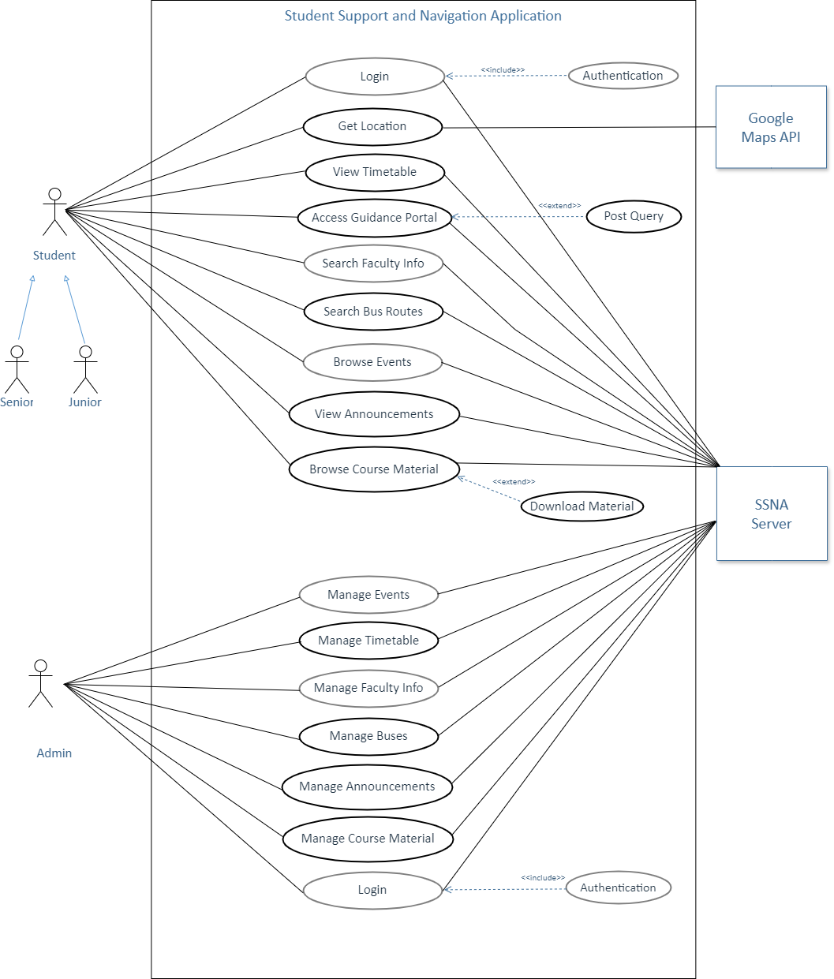

### Figure 1. Use Case Diagram

## **Activity Diagram**

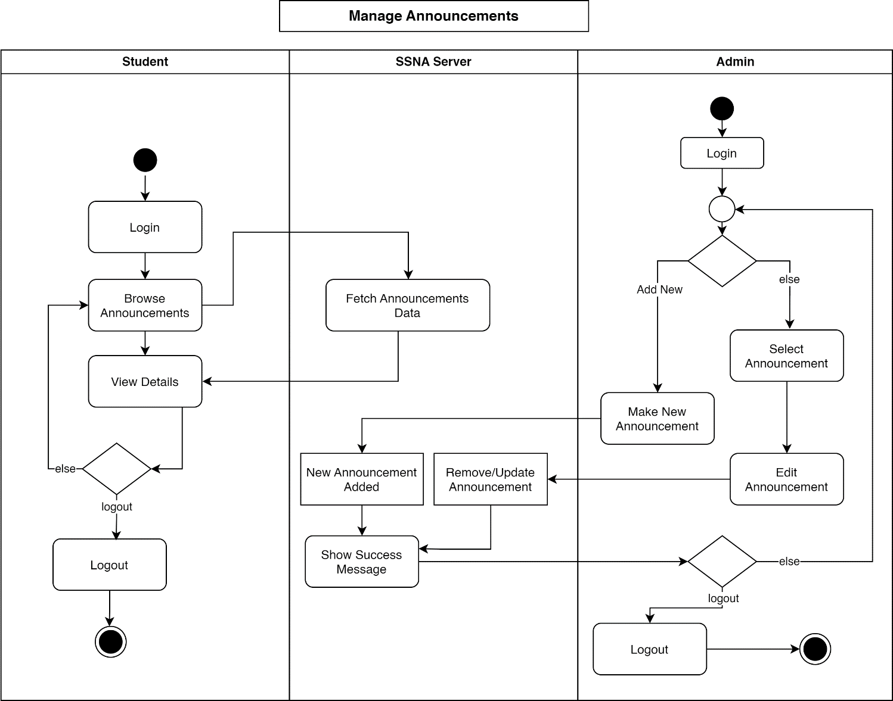

### Figure 2. Activity Diagram 1

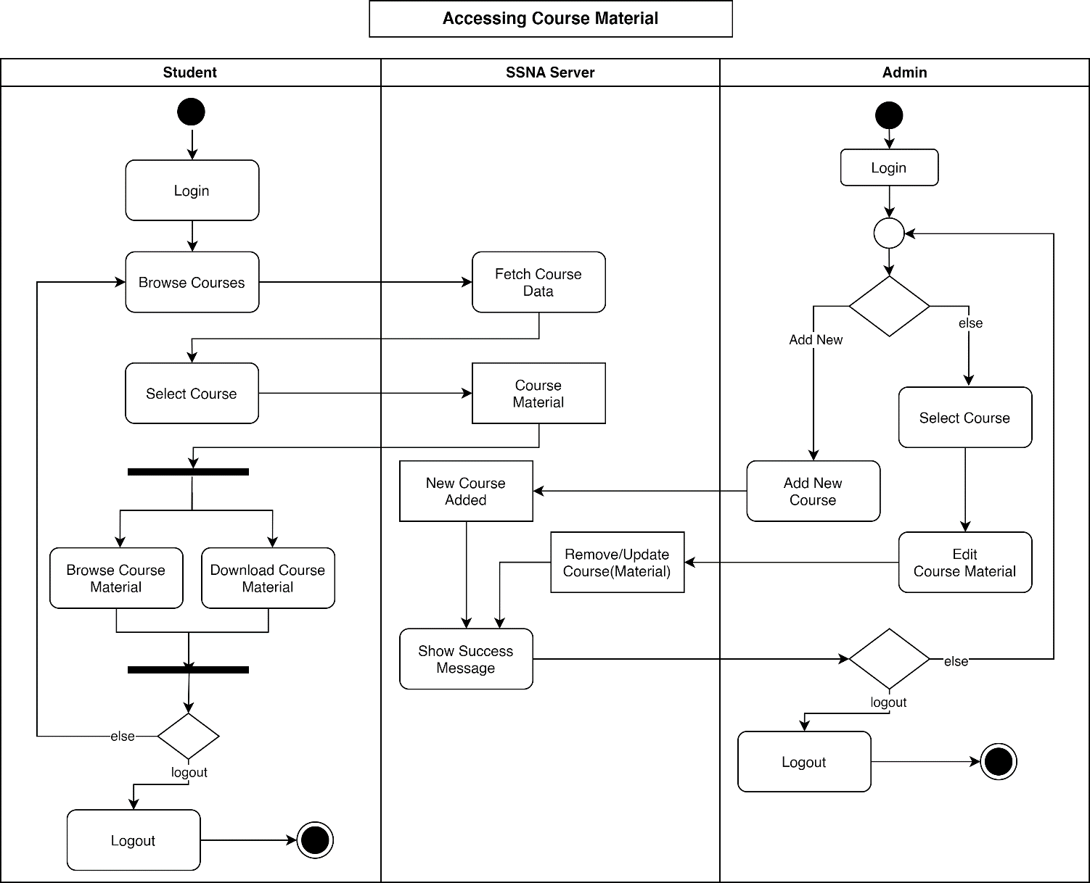

### Figure 3. Activity Diagram 2

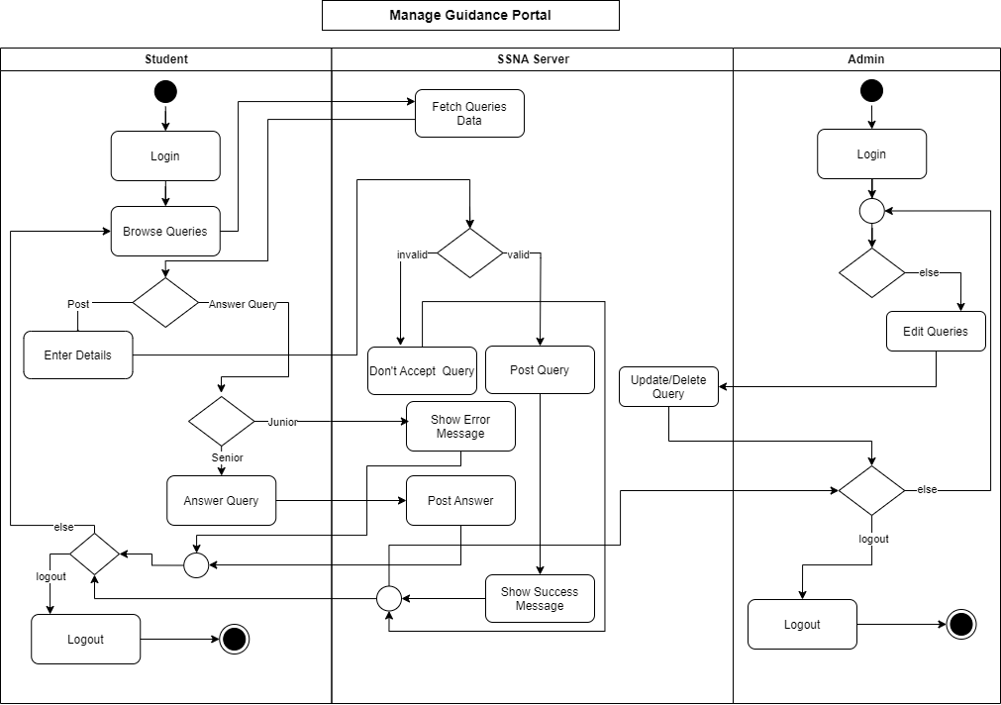

### Figure 4. Activity Diagram 3

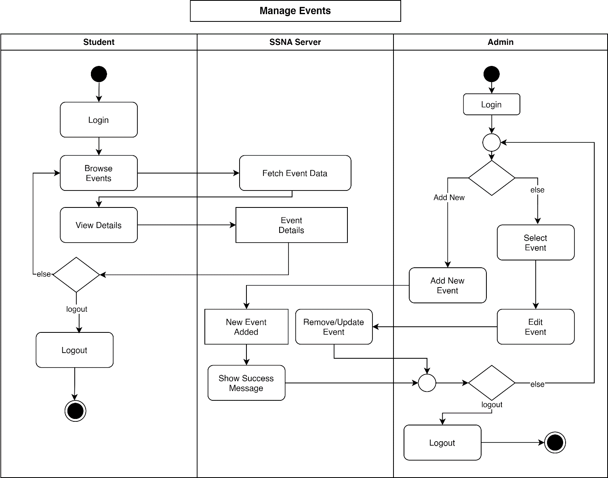

### Figure 5. Activity Diagram 4

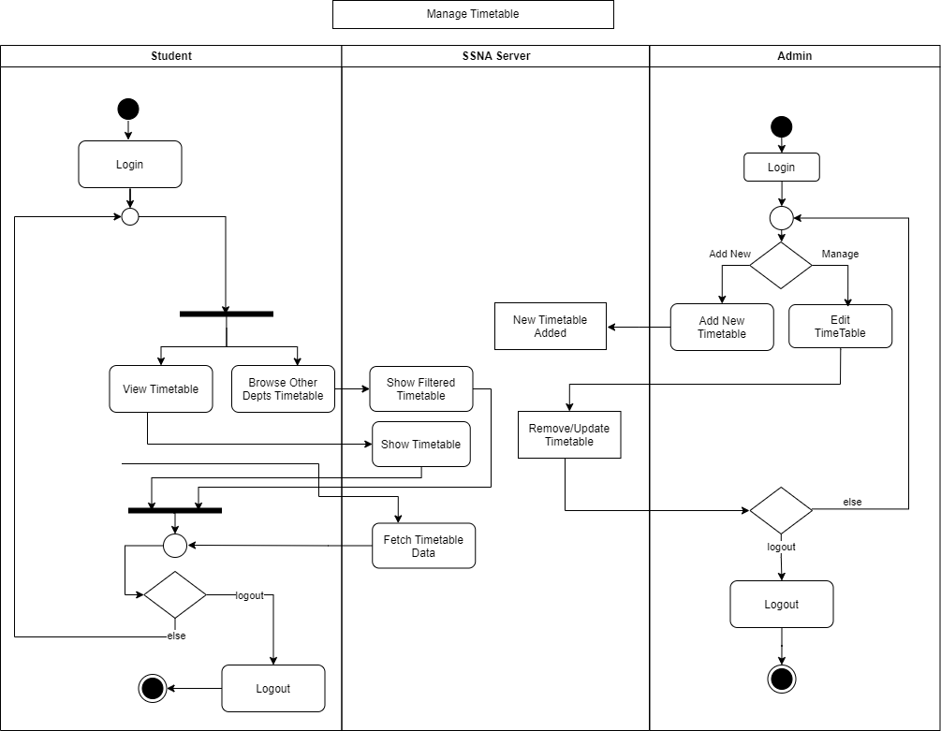

### Figure 6. Activity Diagram 5

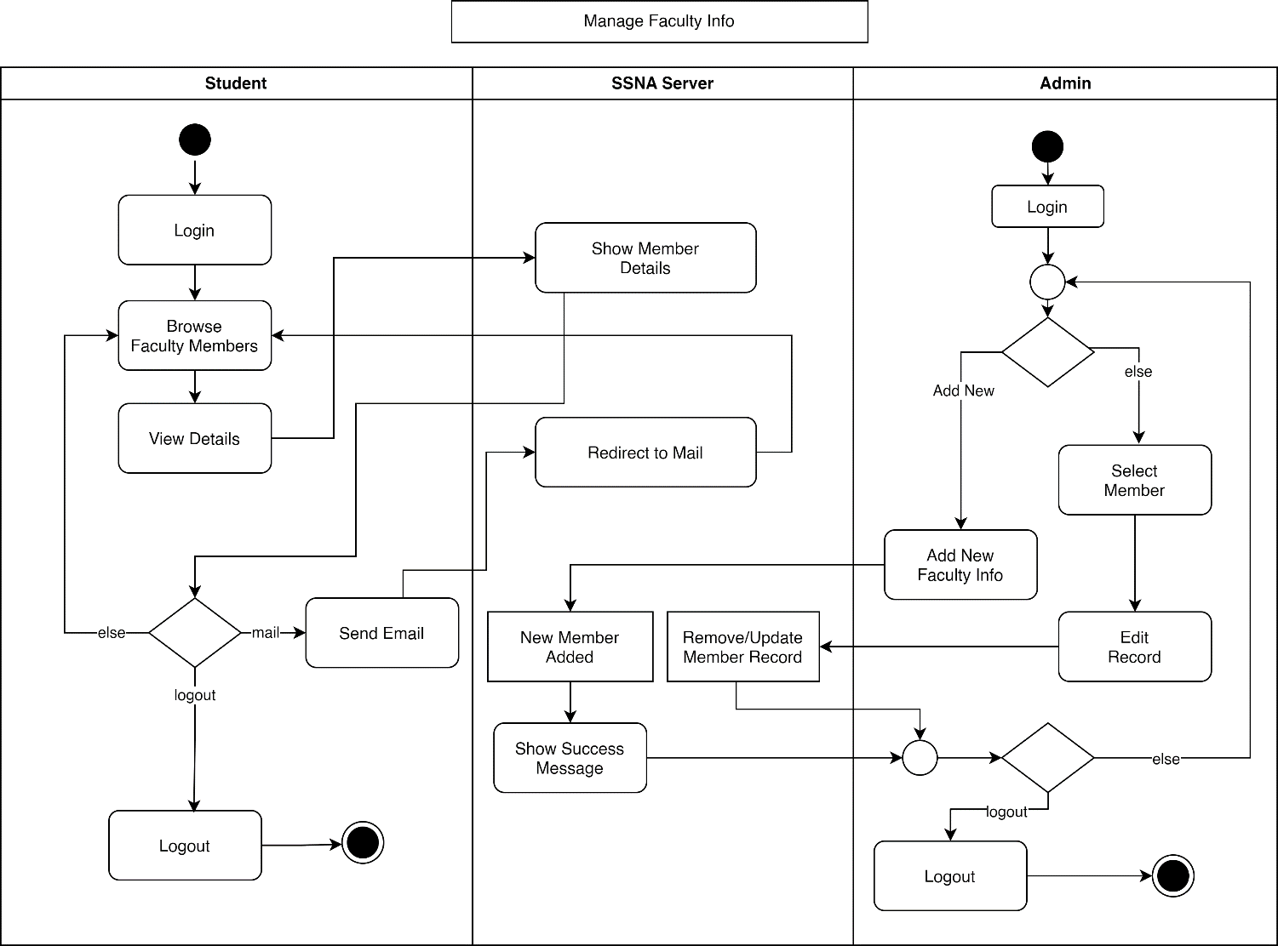

### Figure 7. Activity Diagram 6

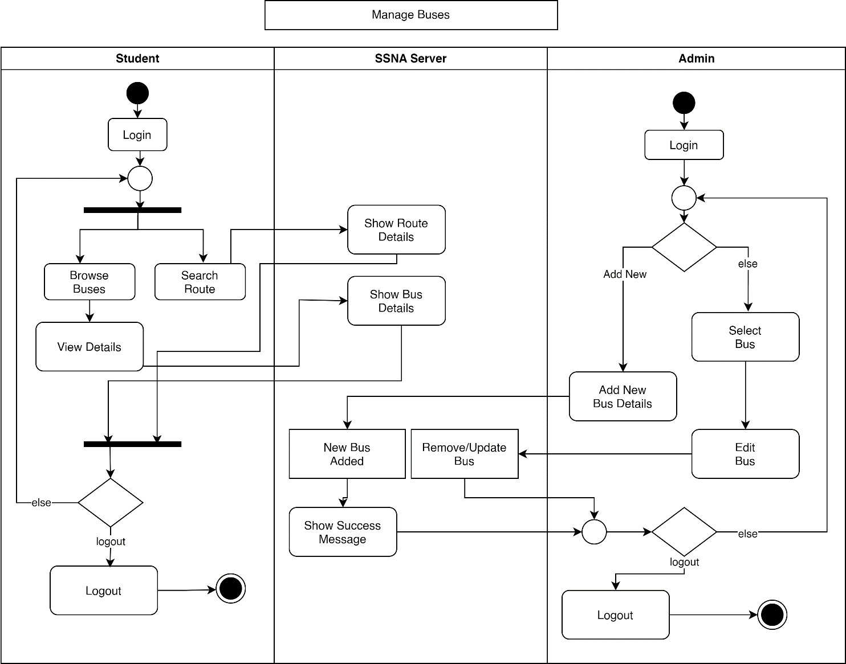

### Figure 8. Activity Diagram 7

## **System Sequence Diagram**

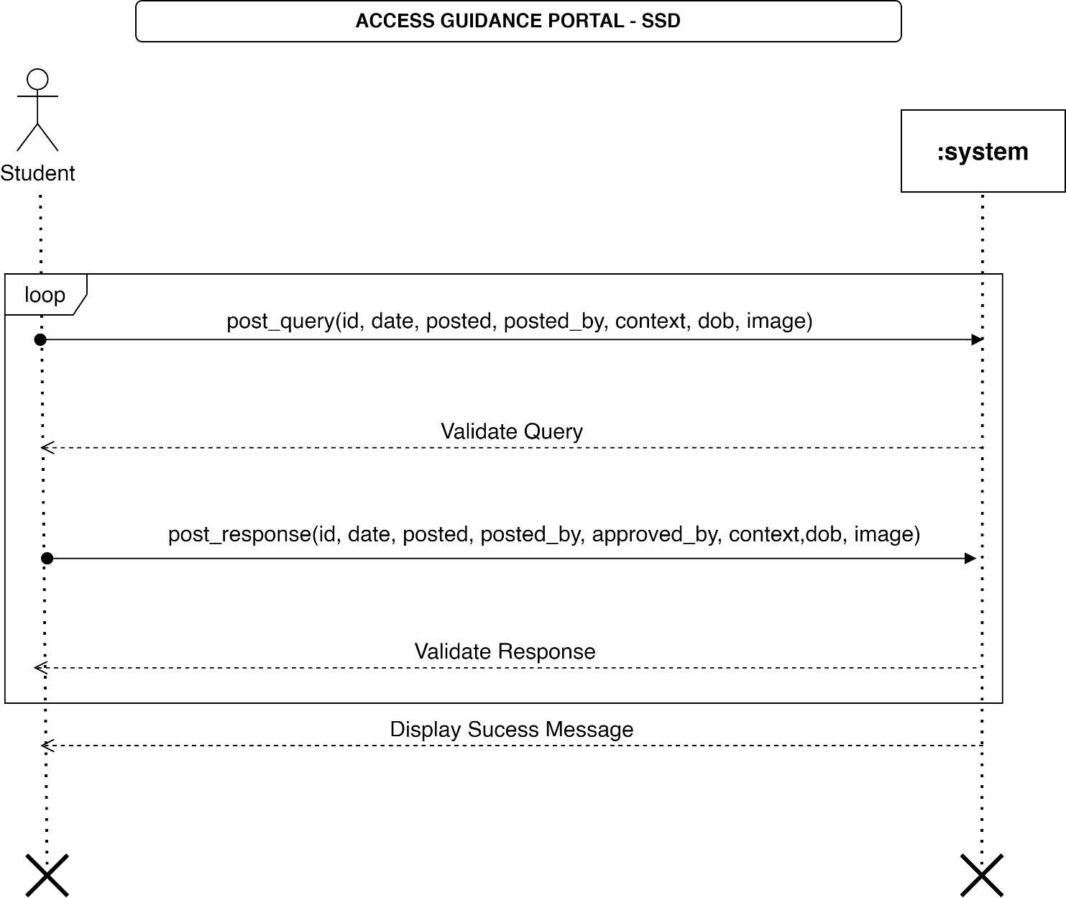

### Figure 9. System Sequence Diagram (SSD) 1

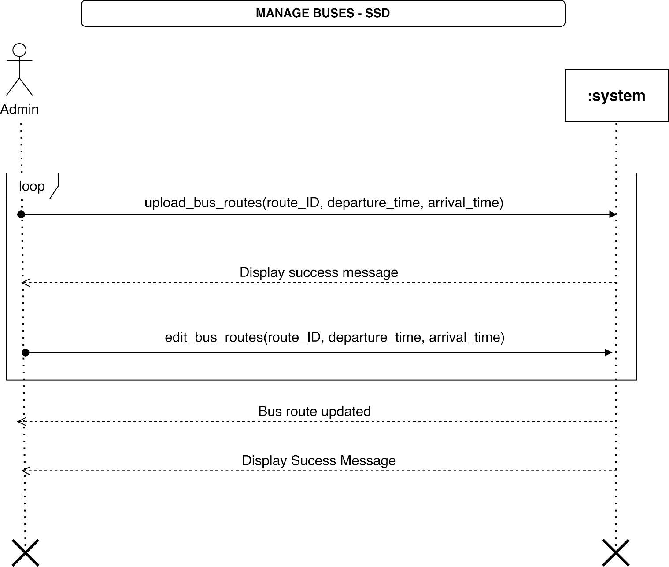

### Figure 11. System Sequence Diagram (SSD) 2

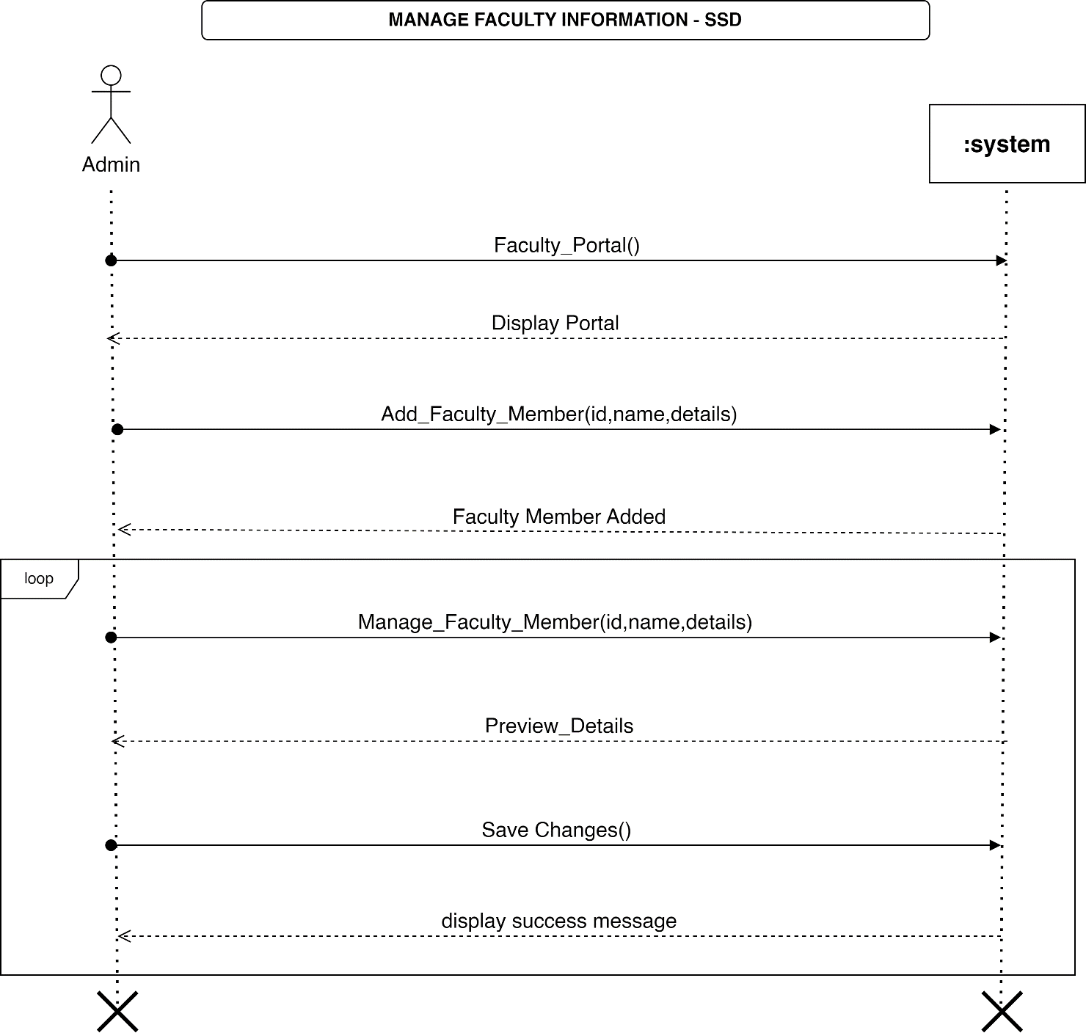

### Figure 12. System Sequence Diagram (SSD) 3

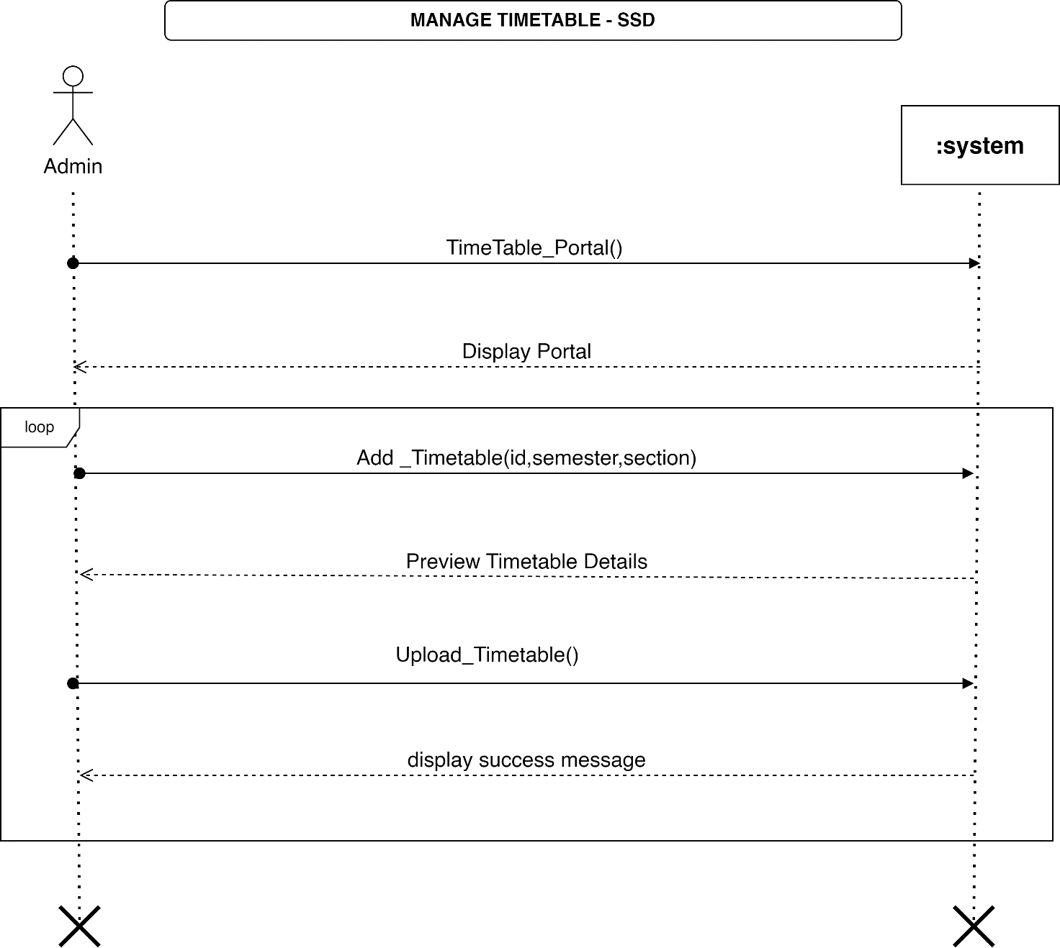

### Figure 13. System Sequence Diagram (SSD) 4

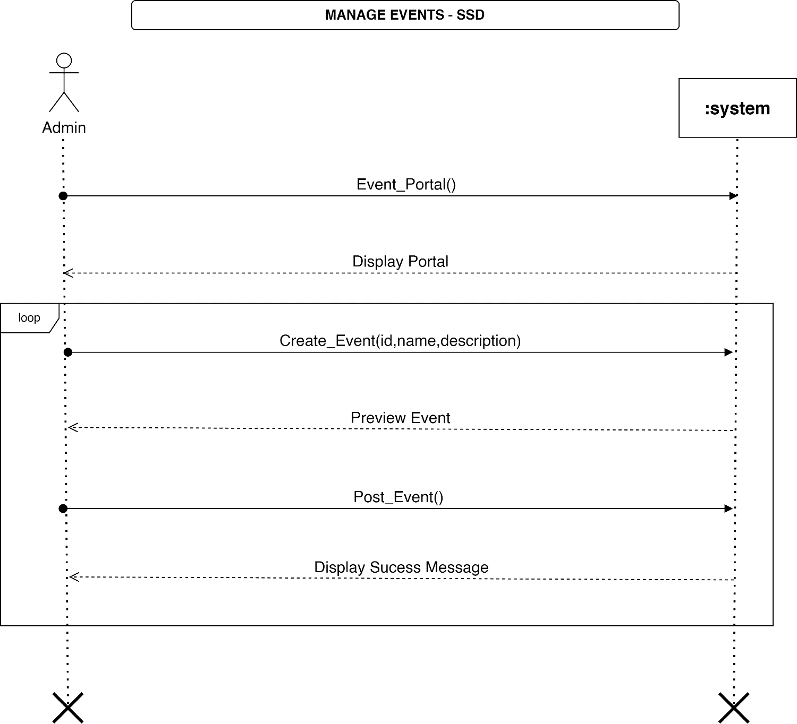

### Figure 14. System Sequence Diagram (SSD) 5

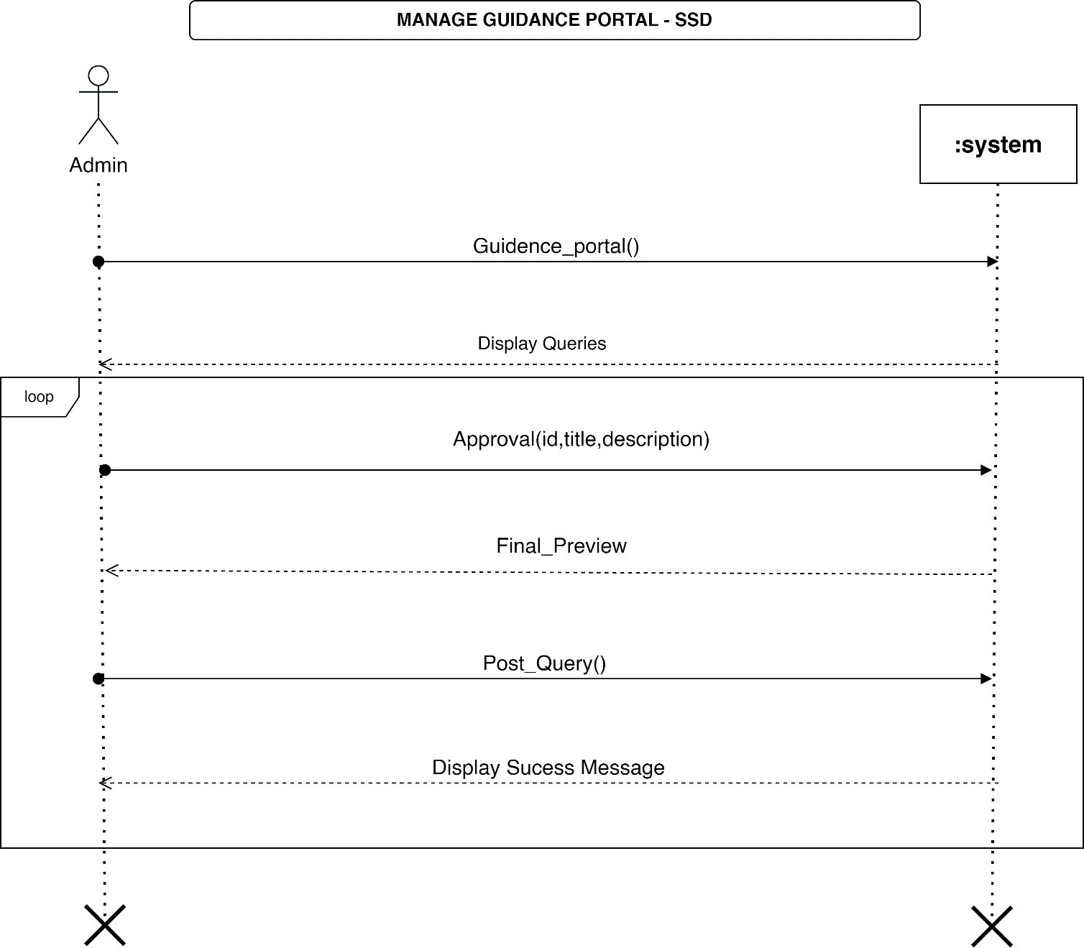

### Figure 15. System Sequence Diagram (SSD) 7

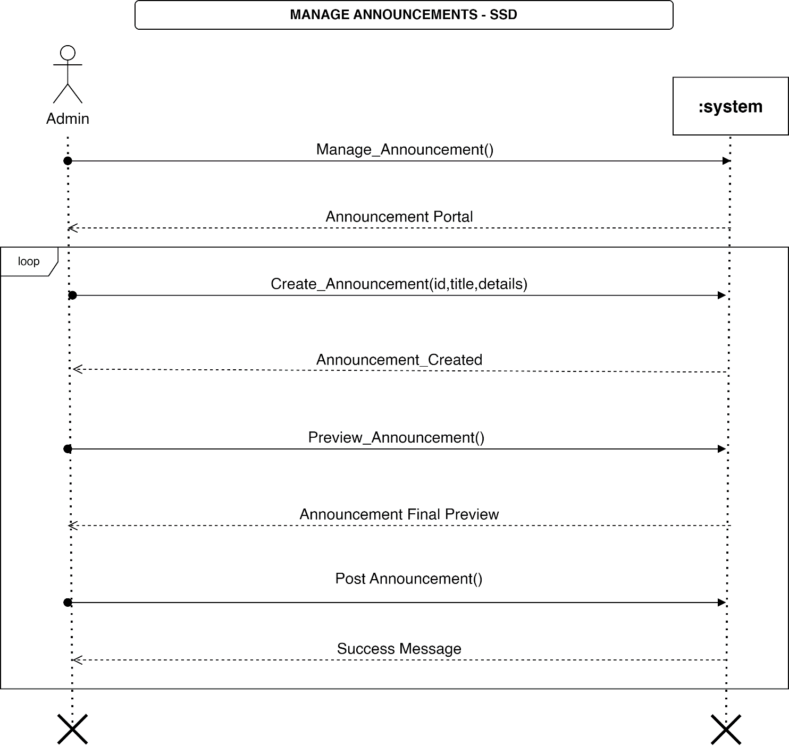

### Figure 16. System Sequence Diagram (SSD) 8

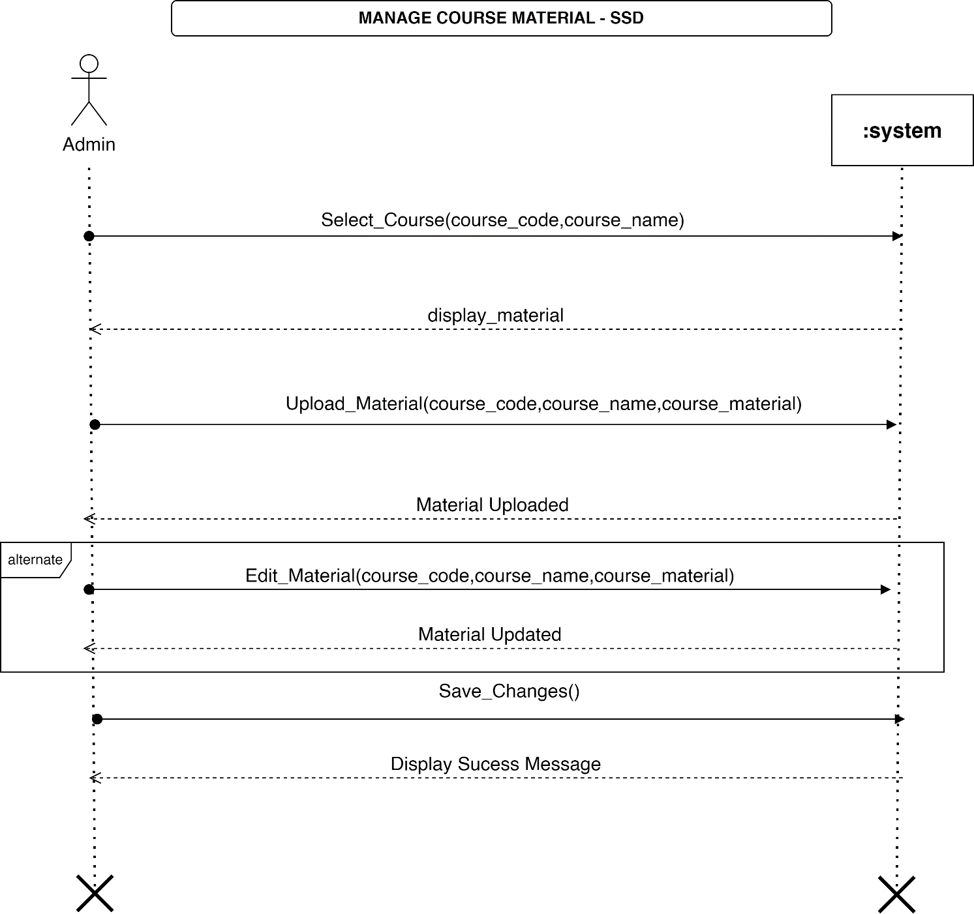

### Figure 17. System Sequence Diagram (SSD) 9

## **Component Diagram**

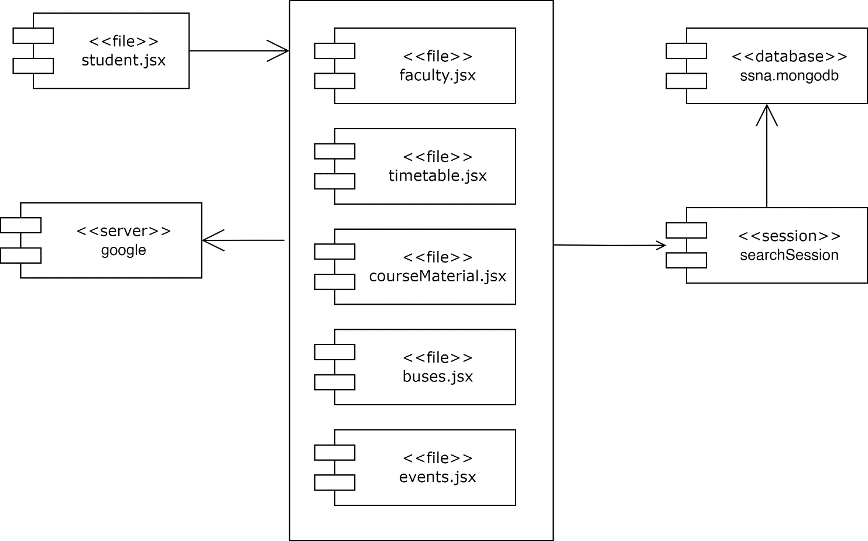

### Figure 18. Component Diagram

## **Data Flow Diagram**

**LEVEL - 0**



### Figure 19. Data Flow Diagram 1

**LEVEL - 1**

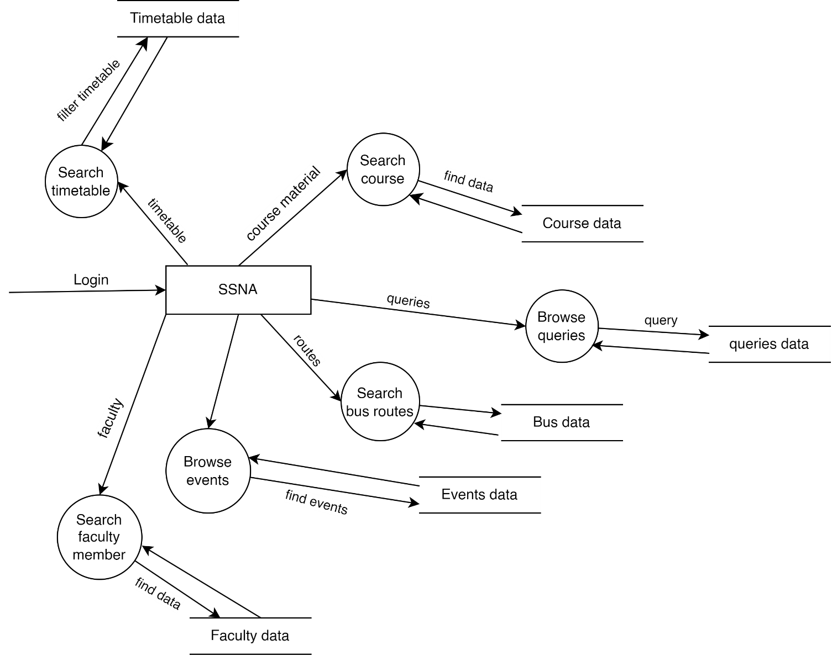

### Figure 20. Data Flow Diagram 2

**LEVEL – 2**

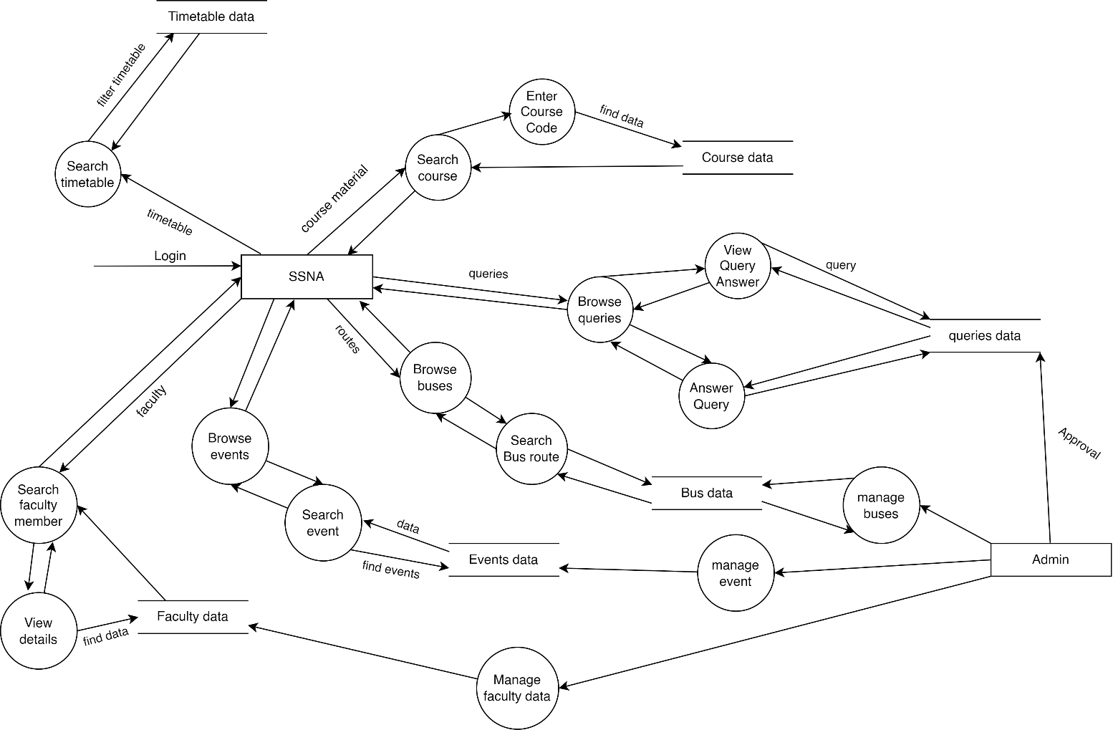

### Figure 21. Data Flow Diagram 3

## **Database Schema**

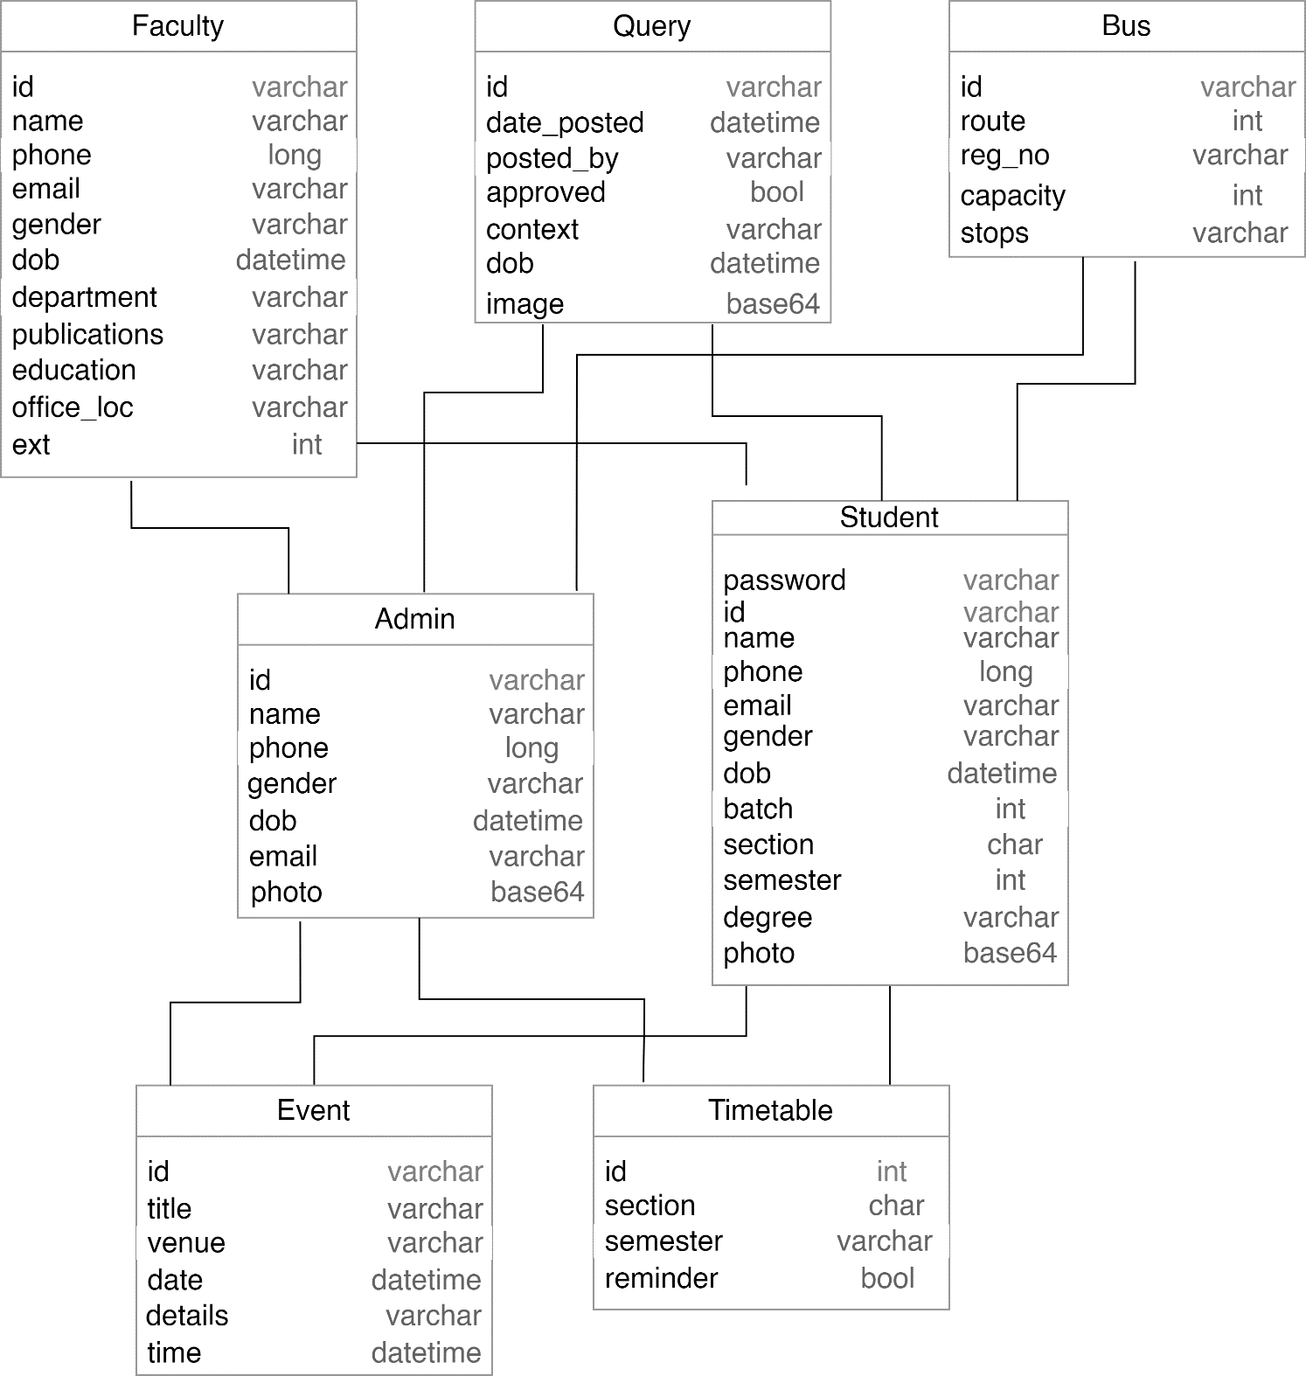

### Figure 22. Database Schema 1